EXP -1

Aim:- To understand DevOps: Principles, practices, and DevOps Engineer role and responsibilities

What is DevOps?

DevOps stands for development and operations. It’s a practice that aims at merging development, quality assurance, and operations (deployment and integration) into a single, continuous set of processes. This methodology is a natural extension of Agile and continuous delivery approaches.

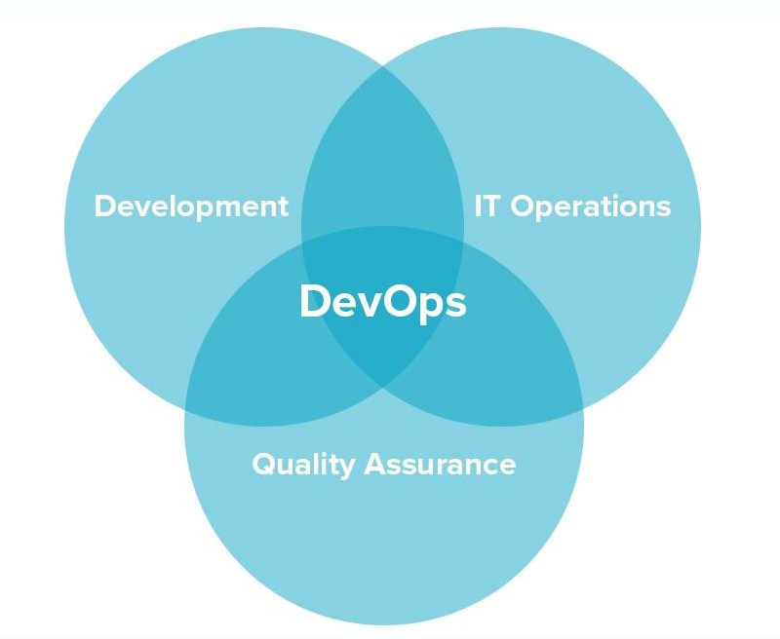

By adopting DevOps companies gain three core advantages that cover technical, business, and cultural aspects of development.  
  
**Higher speed and quality of product releases.** DevOps speeds up product release by introducing [continuous delivery](https://www.altexsoft.com/blog/business/continuous-delivery-and-integration-rapid-updates-by-automating-quality-assurance/), encouraging faster feedback, and allowing developers to fix bugs in the system in the early stages. Practicing DevOps, the team can focus on the quality of the product and automate a number of processes.  
  
**Faster responsiveness to customer needs.**With DevOps, a team can react to change requests from customers faster, adding new and updating existing features. As a result, the time-to-market and value-delivery rates increase.  
  
**Better working environment.** DevOps principles and practices lead to better communication between team members, and increased productivity and agility. Teams that practice DevOps are considered to be more productive and cross-skilled. Members of a DevOps team, both those who develop and those who operate, act in concert.  
  
These benefits come only with the understanding that DevOps isn’t merely a set of actions, but rather a philosophy that fosters cross-functional team communication. More importantly, it doesn’t require substantial technical changes as the main focus is put on altering the way people work. The whole success depends on adhering to DevOps principles.

DevOps Princpal

The principles of DevOps are centered around collaboration, automation, continuous improvement, and end-to-end responsibility.

Collaboration: DevOps emphasizes the integration of development and operations teams, with shared responsibility from beginning to end

Automation: Automation of the software development lifecycle is a fundamental principle of DevOps, allowing teams to automate as much of the software development lifecycle as possible

Continuous Improvement: DevOps promotes a culture of continuous improvement, where teams constantly strive to enhance their processes and minimize waste

End-to-End Responsibility: DevOps teams own a feature or project throughout the complete lifecycle from idea to delivery, leading to higher quality output

DevOps Practices

DevOps practices are a set of principles and methods that aim to improve collaboration, communication, and automation between development and operations teams.

**Continuous Integration and Continuous Delivery (CI/CD)**: This practice involves automating the build, test, and deployment processes to ensure that code changes are quickly and safely delivered to production

**Infrastructure as Code (IaC):** This practice involves managing infrastructure through code, allowing teams to version control, test, and automate infrastructure changes

**Monitoring and Observability**: This practice involves monitoring the performance and availability of applications and infrastructure, and using data to gain insights and improve the system

**Agile Project Management:** This practice involves using agile methodologies to manage projects, allowing teams to quickly adapt to changing requirements and deliver value to customers

**Collaboration and Communication:** DevOps emphasizes the importance of collaboration and communication between development and operations teams, as well as other stakeholders

**Automation:** DevOps promotes the automation of as many processes as possible, including testing, deployment, and infrastructure management

DevOps Engineer role and responsibilities

A DevOps Engineer is responsible for ensuring the smooth operation of a company's IT infrastructure and facilitating collaboration between development and operations teams

**Understanding customer requirements and project KPIs**: DevOps Engineers need to have a deep understanding of customer needs and project goals to ensure that the software development process aligns with these requirements

**Deploying and managing code changes:** They work with developers to deploy and manage code changes, ensuring that the software is delivered efficiently and effectively

**Ensuring system availability and performance**: DevOps Engineers are responsible for maintaining the availability and performance of systems, ensuring that they are up and running smoothly

**Implementing and managing DevOps approach**: They are responsible for implementing and managing the DevOps approach within an organization, promoting collaboration, automation, and continuous improvement

**Building and implementing new development tools and infrastructure**: DevOps Engineers help plan projects and are involved in project management decisions, building and implementing new development tools and infrastructure

**Automating and improving development and release processes:** They work on ways to automate and improve development and release processes, reducing errors and improving customer experience

**Testing and examining code:** DevOps Engineers test and examine code written by others, analyzing results and ensuring that systems are safe and secure against cybersecurity threats

**Collaboration and communication:** They need excellent communication and coordination skills to successfully integrate development and operations teams, as well as other stakeholders